Session 8

Depth Perception and Applications in Robotics

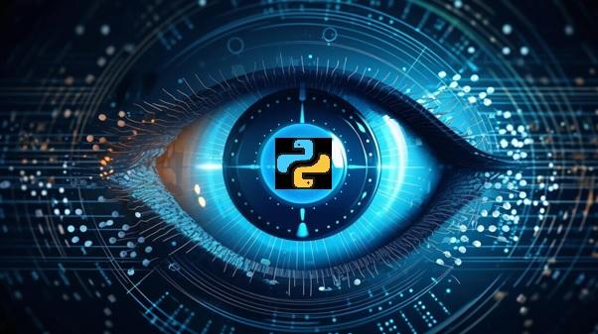

This session delves into the intricacies of depth perception, elucidating its role in robotics and exploring a myriad of applications.

Objectives

* Explain the basics of stereo vision for depth perception
* Describe LiDAR technology and its role in depth sensing
* Describe the concept of depth perception and its applications in robotics
* Explain the fundamentals of point clouds
* Illustrate processing, analysis, filtering, segmentation techniques, and feature extraction from point clouds
* Explain the integration of depth perception in robotics
* Illustrate challenges and future developments in applying depth perception to autonomous vehicles

8.1 Principles of Stereo Vision and LiDAR

Stereo Vision and LiDAR are two techniques that are used by modern robotics to visually sense the world. Stereo vision and LiDAR are used extensively in robotics to make the world sensing to those same as human vision.

8.1.1 Basics of Stereo Vision

Stereo vision, also known as stereopsis, is a technique used in computer vision and robotics that mimics human binocular vision. It involves capturing and processing images from two or more cameras to perceive depth and create a three-dimensional (3D) representation of the environment.

The working principle of stereo vision includes:

Applications of stereo vision are as follows:

**Stereo Correspondence and Disparity:** Stereo vision involves capturing a scene from two or more vantage points to simulate human binocular vision. The process of stereo correspondence aims to match corresponding points in the images from different viewpoints, establishing a correspondence map. Disparity, the pixel-wise difference between the positions of corresponding points, is computed to perceive depth information.

**Depth Map Generation:** By analyzing the computed disparities, a depth map is generated, representing the distances of objects within the scene. This depth information is crucial for applications like 3D reconstruction, object detection, and autonomous navigation, making stereo vision a fundamental technique in computer vision.

8.1.2 LiDAR Technology

Applications of LiDAR are as follows:

**Point Cloud Generation from LiDAR:** LiDAR technology generates a point cloud, a collection of 3D points representing the surfaces of objects in the scanned area. Each point in the cloud corresponds to a location in the physical space, providing a comprehensive and accurate representation. Point clouds from LiDAR find applications in fields such as autonomous vehicles, forestry, urban planning, and archaeology.

8.2 Depth Perception Techniques

Depth perception is a cornerstone in robotics, unlocking the spatial dimension for machines to interpret and navigate their environment. There are various techniques employed for depth perception, shedding light on their principles and applications in the realm of robotics.

8.2.1 Understanding Depth Perception

Depth perception, the ability to perceive the world in three dimensions, is a cognitive marvel that robots strive to emulate. By comprehending the spatial relationships and distances between objects, robots equipped with depth perception capabilities can navigate, interact, and function more effectively.

Techniques for depth perception includes:

**Monocular and Binocular Depth Cues:** Depth perception relies on various cues, including monocular cues observed with one eye and binocular cues based on the convergence of both eyes. Monocular cues, such as relative size, interposition, and linear perspective, provide depth information with a single viewpoint. Binocular cues, like retinal disparity and convergence, leverage the slight differences in the images seen by each eye, enabling the brain to perceive depth.

**Role of Perspective in Depth Perception:** Perspective plays a crucial role in depth perception. Objects appear smaller as they move farther away, and parallel lines converge toward a vanishing point. Understanding these perspective cues helps the brain interpret spatial relationships, contributing to an accurate perception of depth in a visual scene.

8.2.2 Applications in Robotics

In the realm of robotics, the application of point cloud processing extends to enhancing perception capabilities. By leveraging feature extraction from point clouds, robots can discern and interact with objects more intelligently, facilitating tasks such as precise manipulation, object recognition, and navigation in dynamic environments. This heightened perception contributes to the overall efficiency and adaptability of robotic systems in diverse applications, from manufacturing and logistics to autonomous vehicles and assistive robotics.

**Applications of Depth Perception in Real-world Robotics**: Applications in robotics include:

The comprehension of depth perception is fundamental for robots to operate effectively and safely in real-world scenarios, making it a crucial aspect of robotic systems design and implementation.

**Robotics Navigation and Obstacle Avoidance**: The importance of robotics include:

8.3 Point Cloud Processing Basics

Point clouds serve as a rich source of spatial information, capturing the intricate details of a physical environment. The fundamental aspects of point cloud processing are explored from their introduction to the techniques used for analysis and feature extraction.

8.3.1 Introduction to Point Clouds

Point clouds are 3D representations of surfaces, constructed by collecting a multitude of points in space. These points, often obtained through technologies such as LiDAR or stereo vision, collectively create a detailed map of an object or environment.

**Characteristics**: Characteristics of point clouds include:

In point cloud, the developer can use open3d library of python to render the point cloud and see how point cloud looks.

To install all the necessary packages use this command in command line:

|  |
| --- |
| pip install open3d |

To download the point cloud file down any sample from internet.

Code Snippet 1 demonstrates the rendering of the point cloud using Open 3d library.

**Code Snippet 1**:

|  |
| --- |
| import numpy as np  import open3d as o3d  print("Load a ply point cloud, print it, and render it")  ply_point_cloud = './airplane.ply'  pcd = o3d.io.read_point_cloud(ply_point_cloud)  print(pcd)  print(np.asarray(pcd.points))  o3d.visualization.draw_geometries([pcd]) |

In Code Snippet 1, the developer utilizes the Open3D library to load a 3D point cloud from a PLY file named 'airplane.ply'. It prints information about the point cloud object, including its geometry details, and displays the coordinates of the points as a NumPy array. Finally, it visualizes the point cloud using the draw_geometries function from Open3D, providing an interactive 3D rendering of the loaded point cloud. Figure 8.1 shows the output of Code Snippet 1 rendered ply file. Figure 8.2 shows the output of Code Snippet 1.

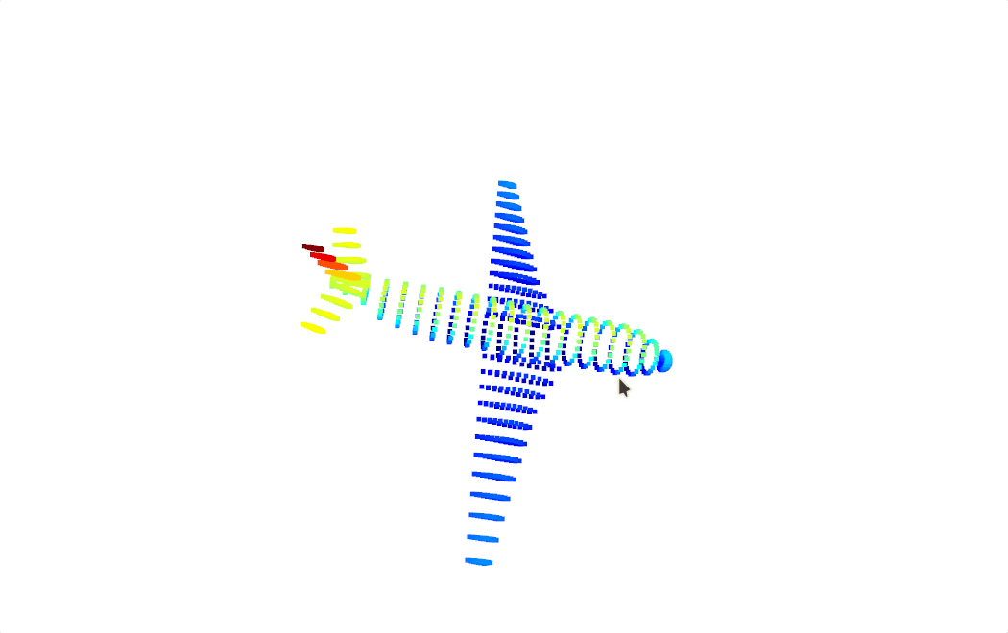Figure 8.1: Output of Code Snippet 1 Rendered Ply File

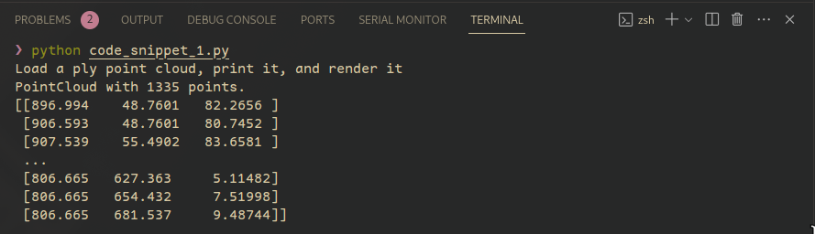

Figure 8.2: Output of Code Snippet 1

The output consists of three parts: Firstly, it confirms the successful loading of a point cloud with 1335 points. Secondly, it prints a snippet of the point coordinates as a NumPy array, illustrating the spatial distribution. Lastly, a separate window opens, visually presenting an interactive 3D rendering of the loaded point cloud, enabling exploration of its geometry as shown in Figure 8.1.

8.3.2 Processing and Analysis

Processing and analyzing point clouds involve intricate techniques to derive meaningful insights from the voluminous 3D data. These steps encompass tasks such as filtering, segmentation, and feature extraction, enabling a comprehensive understanding of spatial structures, object relationships, and environmental characteristics. The combination of these processes lays the foundation for applications spanning robotics, autonomous systems, urban planning, and various domains reliant on detailed 3D scene interpretation.

To use Point cloud effectively, it has to be processed and analyzed.

Processing Steps of point cloud include:

Analysis techniques of point cloud include:

8.3.3 Filtering and Segmentation Techniques

Filtering and Segmentation techniques are important step before any data is processed in real life. As video and image data is such a large dataset these techniques become even more important.

**Filtering**:

**Noise Removal**: Eliminate outliers and sensor-generated noise for cleaner data.

**Smoothing**: Apply filters to reduce irregularities and create a smoother representation.

**Segmentation**:

**Region Growing**: Identify connected regions with similar properties.

These are some of the techniques that are used for filtering and segmentation:

**Plane Segmentation**: Separate point clouds into distinct planes, aiding in surface analysis.

**Statistical Outlier Removal:** This technique identifies and removes outliers in the point cloud based on statistical measures, ensuring the accuracy of the data by eliminating anomalies.

**Voxel Grid Downsampling:** Voxel grid downsampling involves dividing the point cloud into voxel grids and retaining a single point per grid, reducing the overall density and preserving key features.

**Pass-Through Filtering:** Pass-through filtering sets limits along specified axes to filter out points outside a defined range, focusing on a particular region of interest.

**Radial Basis Function (RBF) Smoothing:** RBF smoothing applies mathematical functions to interpolate point values, producing a smoother representation of the point cloud.

**Euclidean Clustering:** Euclidean clustering groups nearby points based on their spatial proximity, aiding in the identification of distinct objects or surfaces.

**Region Growing:** Region growing identifies connected regions in the point cloud, facilitating the segmentation of surfaces or objects with similar properties.

**Connected Components Labeling:** Connected components labeling assigns labels to connected groups of points, aiding in the identification and differentiation of separate structures.

**Planar Segmentation:** Planar segmentation extracts planar surfaces from the point cloud, providing information about flat structures within the environment.

8.3.4 Feature Extraction from Point Clouds

Feature extraction from point clouds involves identifying distinctive characteristics within the 3D data that contribute to a richer understanding of the environment. These features can include edges, corners, keypoints, or other salient points that provide valuable information for subsequent analysis. Extracting meaningful features is crucial for tasks such as object recognition, scene understanding, and generating descriptors that capture the unique attributes of structures within the point cloud.

Features from point clouds include:

Applications of point cloud include:

Point cloud processing, from acquisition to feature extraction, is a critical step in leveraging 3D spatial data for applications in robotics, computer vision, and various other fields.

8.4 Applications in Robotics and Autonomous Vehicles

Robotics and autonomous vehicles leverage depth perception technologies to enhance their capabilities and navigate dynamic environments. The integration of depth perception in robotics is explored along with challenges and future developments in this rapidly evolving field.

8.4.1 Integration of Depth Perception in Robotics

The integration of depth perception in robotics signifies the incorporation of advanced sensor technologies, such as LiDAR or stereo cameras, to provide a three-dimensional understanding of the surroundings. This integration empowers robots with the ability to accurately perceive distances, enabling applications like precise navigation, obstacle avoidance, and informed decision-making in dynamic and complex environments. From autonomous vehicles to robotic manipulation, depth perception enhances the versatility and efficiency of robotic systems across various domains.

**Enhanced Navigation**:

Following points discuss how depth perception enhance navitgation in robots:

**Obstacle Avoidance**: Robots use depth perception to detect and navigate around obstacles, ensuring safe movement in cluttered environments.

**Terrain Understanding**: Depth perception aids in recognizing changes in terrain, helping robots adapt their locomotion for various surfaces.

**Object Manipulation**:

Following points discuss how depth perception help robots for object manipulation:

**Precise Grasping**: Robots equipped with depth perception can grasp and manipulate objects with accuracy, as they can estimate the distance and shape of the objects.

**Human-Robot Interaction**:

Following points discuss how depth perception can increase the synergy between robots and human:

**Gesture Recognition**: Depth perception enables robots to interpret human gestures, facilitating more intuitive communication.

**Safe Collaboration**: Robots can work alongside humans more safely by perceiving their proximity and movements.

**3D Environment Mapping**:

Following point discuss how depth perception can help robots in 3D mapping tasks:

**Spatial Awareness**: Depth perception contributes to creating detailed 3D maps of the environment, allowing robots to comprehend and navigate complex spaces.

**Vision-Based Control**:

Following point discuss how depth perception can help robots to do vision based tasks and control:

**Autonomous Systems**: Depth perception is integral to the autonomy of robots, enabling them to make real-time decisions based on their comprehending of the surroundings.

**Autonomous Vehicles and Depth Sensing:** Depth perception plays a pivotal role in the integration of autonomous vehicles. Depth sensors, such as LiDAR or stereo cameras, enable vehicles to accurately perceive the distance to objects in their surroundings. This is crucial for obstacle detection, path planning, and ensuring safe navigation in dynamic environments.

**Robotics Manipulation and Grasping with Depth Perception:** In robotics manipulation, depth perception enhances the capabilities of robots in tasks such as object grasping. Depth information allows robots to precisely assess the spatial arrangement of objects, improving the accuracy of manipulation and enabling more sophisticated interactions with the environment.

8.4.2 Challenges and Future Developments

Addressing the challenges in depth perception applications involves overcoming issues such as occlusions, varying lighting conditions, and the need for real-time processing. Future developments in this field are expected to focus on advancing sensor technologies, robust algorithms, and adaptive systems capable of handling diverse scenarios, ushering in innovations for improved accuracy and efficiency in depth perception applications.

**Overcoming Challenges in Depth Perception Applications**: the challenges in depth perception include:

**Future Innovations in Robotics and Autonomous Systems**: Future developments include:

The integration of depth perception in robotics presents exciting opportunities for innovation. Overcoming current challenges and embracing future developments play a pivotal role in realizing the full potential of depth sensing technologies in autonomous systems.

**8.5 Summary**

* Stereo vision utilizes two cameras to calculate depth, while LiDAR measures distances using laser beams.
* Depth perception involves perceiving the world in three dimensions, employing techniques such as stereo vision, monocular cues, motion parallax, and focus cues.
* Point clouds are 3D representations created by collecting numerous points in space, with processing steps including data acquisition, registration, downsampling, and normalization.
* Analysis techniques for point clouds encompass surface reconstruction, object recognition, and change detection.
* Integration of depth perception in robotics enhances navigation, object manipulation, and human-robot interaction.
* Applications include obstacle avoidance, terrain understanding, precise grasping, 3D environment mapping, and vision-based control.
* Challenges in depth perception include real-time processing, adaptation to dynamic environments, and sensor limitations.
* Future developments involve advanced sensor technologies, ML integration, and standardized depth data formats.
* Depth perception is fundamental for robots, providing the ability to comprehend and interact with a 3D environment, with ongoing advancements shaping the field.

**8.6 Check Your Progress**

1. What is the primary role of LiDAR technology in robotics?

|  |  |  |  |
| --- | --- | --- | --- |
| **A** | Object recognition | **B** | Depth sensing |
| **C** | Surface reconstruction | **D** | Human robot interaction |

1. Which of the following techniques utilize the slight disparities between images captured by two or more cameras to calculate depth?

|  |  |  |  |
| --- | --- | --- | --- |
| **A** | Monocular cues | **B** | Motion parallax |
| **C** | Stereo vision | **D** | Focus cues |

1. What is the common application of point clouds in robotics?

|  |  |  |  |
| --- | --- | --- | --- |
| **A** | Image recognition | **B** | Audio processing |
| **C** | 3D environment mapping | **D** | Temperature sensing |

1. In point cloud processing, what is a key step in downsizing the data without losing essential details?

|  |  |  |  |
| --- | --- | --- | --- |
| **A** | Normalization | **B** | Registration |
| **C** | Downsampling | **D** | Analysis |

1. What is one of the challenges associated with depth perception in robotics?

|  |  |  |  |
| --- | --- | --- | --- |
| **A** | Reducing sensor accuracy | **B** | Real-time processing |
| **C** | Minimizing sensor range | **D** | Ignoring environmental changes |

**Answers to Check Your Progress**

|  |  |
| --- | --- |
| Question | Answer |
| 1 | B |
| 2 | C |
| 3 | C |
| 4 | C |
| 5 | B |

**Try It Yourself**

1. Apply basic point cloud processing techniques using the Open3d library in Python.
2. Experiment with a depth perception sensor or simulator, such as a stereo camera or depth-sensing software. Capture or simulate a point cloud of a real-world scene and apply basic filtering or segmentation techniques to enhance the interpretation of the environment. Reflect on the challenges encountered and share insights on how depth perception can influence robotic applications.